<https://public.tableau.com/app/profile/shanmuga.priyan.jeevanandam/viz/Shan_Visualizations/Dashboard1?publish=yes>

1). Average Star Rating for Business in each city:

**Geographic Business Distribution:** The map visualizes the geographical distribution of businesses, helping us identify regions with high and low business concentrations. This insight aids in understanding the overall economic landscape and potential market opportunities.

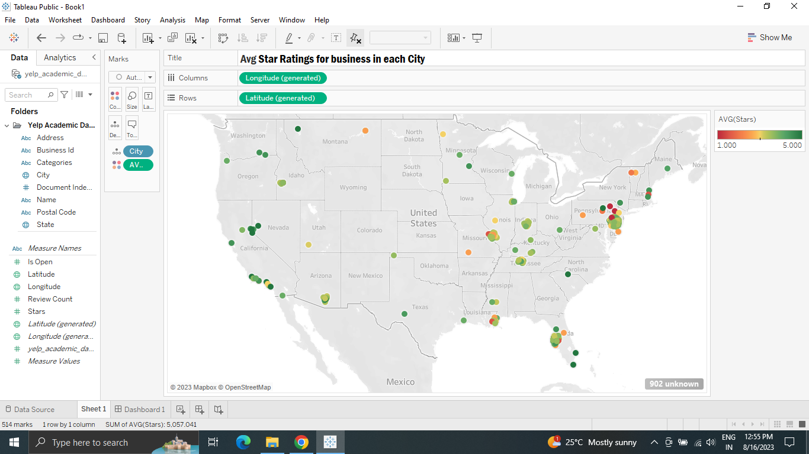

**Rating Analysis through Color Gradients:** By using color gradients for star ratings, you can quickly assess businesses' overall ratings. The color spectrum highlights exceptional and poorly rated businesses, allowing you to make informed decisions about where to dine, shop, or engage in services.

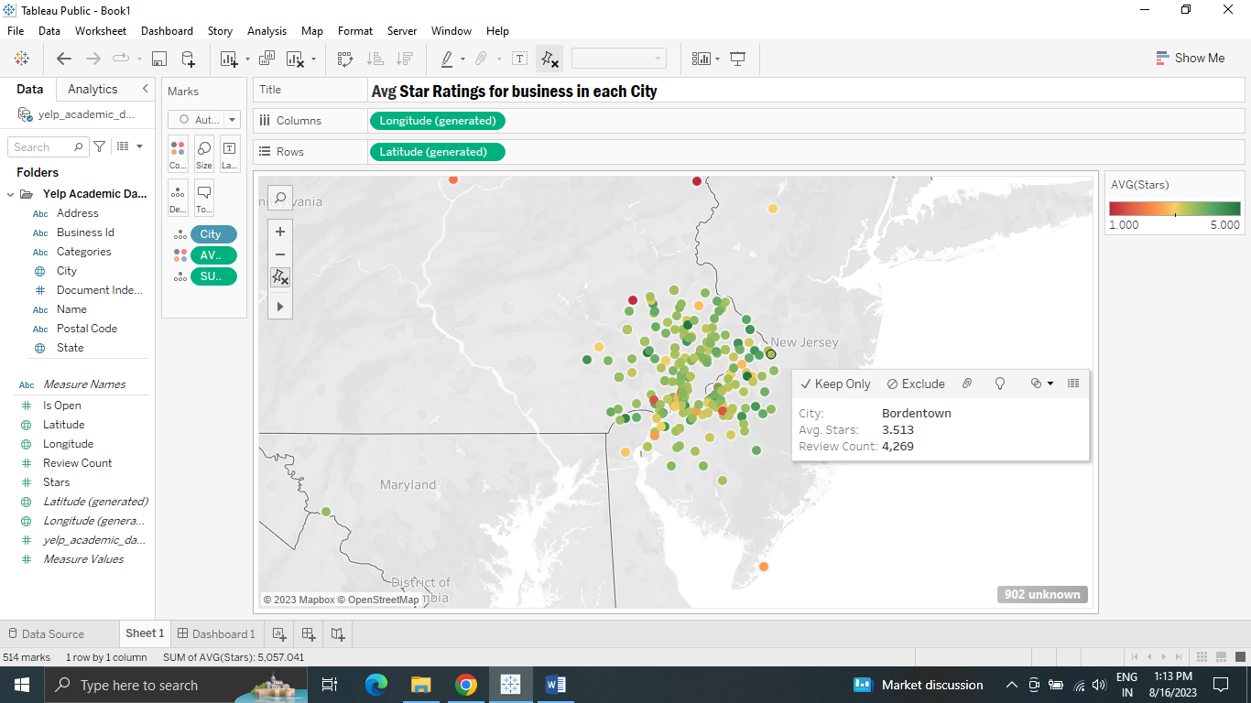

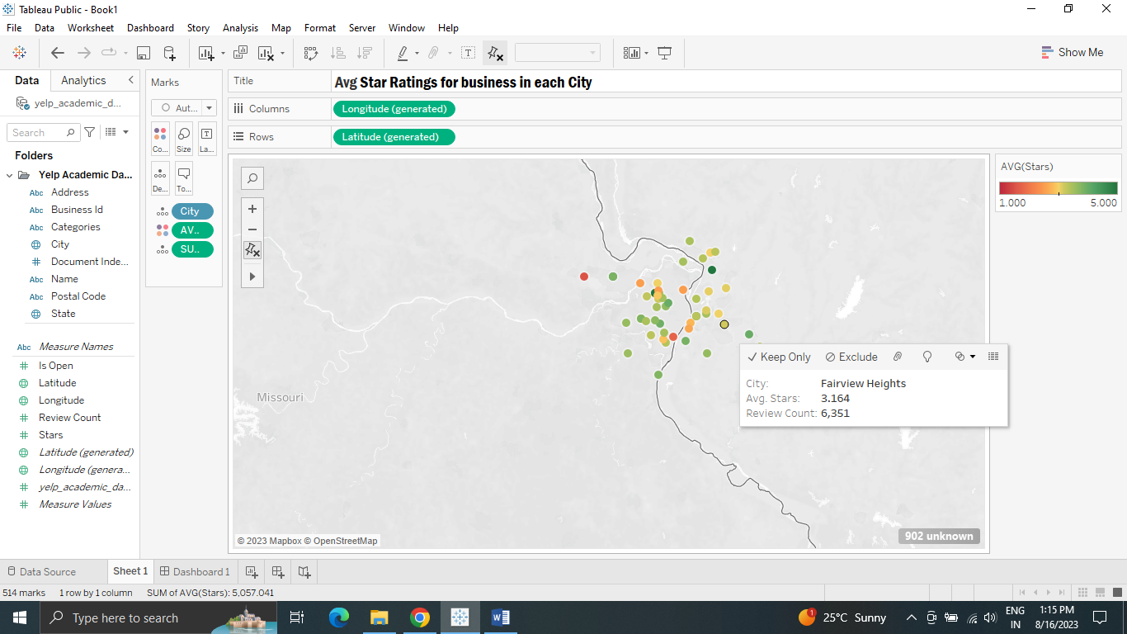

2). Popular business categories and the number of businesses in that category.

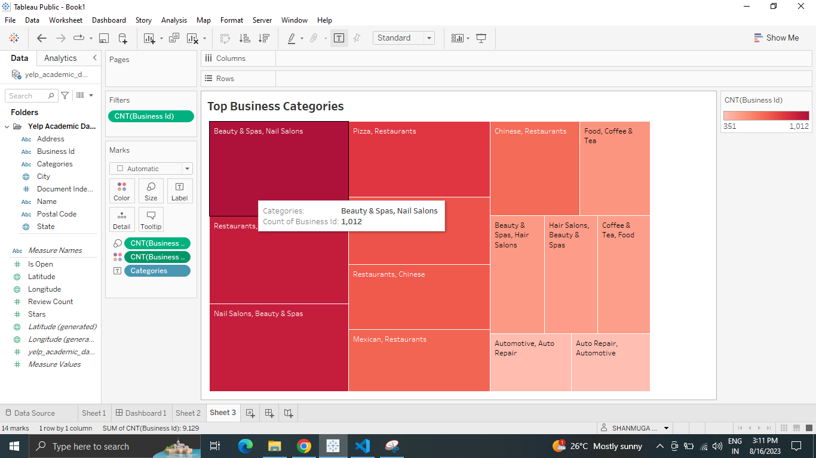

3). States and their average review count.

